Saturday
2020
Season



Information Booklet

Handbook Contents:
Topic:
Canteen
Court Hire
Dogs, skateboards etc.
Fees & fines
Filling in for another team
Finals
First Aid/Physio
Fundraising information
Grading
Ladders
Map for court layout
Net Set Go
Parking
Photos/Video
Quarter & three quarter time
Safety
Scoresheet instructions
Set Up & Pack Up duties
Staff
Training courses
Umpires
Where is my team?
Extreme Weather Policy
Frankston & District Netball Association

BOARD OF MANAGEMENT

President: Corinna Whitnell

Vice President: Shane Matthews

Secretary: Matthew Haanappel OAM

Treasurer: Melissa Kingston

General: Melissa Walker

General: Holly Simmons

General: Dennis Prendergast

STAFF

Saturday Operations Supervisor : Vicki Martin

Saturday Umpires Coordinator: Jeanette Eastland

Volunteer Saturday Administrators: Margaret Page & Anne Tyrell

Volunteer Grading Coodinator : Anne Westmoreland

REPRESENTATIVE PROGRAM
Representative
Teams Managers: One4All Performance squad@fdna.com.au

FINES AND LEVIES (GST INCLUSIVE)

Team Entry: $55.00

Court Fees (for season): Outdoor: $1100.00 (includes ump)
Indoor: $1200.00 (includes ump)

Netball Victoria Membership: Junior: $56.00 (17 & under)
Senior: $76.00 (18 & over)

Incorrect Score Sheet: $10.00
Incorrect Score Sheet (subsequent offence) $20.00

Un-registered Player: $50.00 plus cost of VNA

Ineligible Player:
1st Offence $25.00 or loss of premiership points 2nd Offence $50.00 PLUS loss of points

Forfeit Fine: $160.00
Withdrawal of Team: $250.00 *Plus: Applicable Court and Umpire Fees

Failure to Set Up/Pack Up: $100.00
Failure to attend meeting $150.00

Payments should be made via Direct Credit to the Association’s bank account.

Payment can be made by the following methods:
* Cheque payable to FDNA, posted to P.O. Box 4102, Frankston Heights, 3199
* Direct Bank Deposit or Internet Transfer: details as follows:
Name of Account: Frankston and District Netball Assoc.Inc.
Bank: Bendigo Bank BSB 633-000, Account No. 149358541

COURT HIRE

Indoor | Outdoor
Off Peak  Before 3pm weekdays *  From $20hr | Off Peak  Before 3pm weekdays *  From $10hr
Peak  After 3pm  From $40hr | Peak  After 3pm  From $15hr
With Staff  when office unattended  From $80hr | Saturday Clubs  as per Training Schedule
With Staff  when office unattended  From $80hr | Peak  With Lights  From $25hr
With Staff  when office unattended  From $80hr | Peak Saturday Clubs  With Lights  From $15hr

FUNDRAISING INFORMATION:

Clubs can host BBQ’s to fundraise. BBQ’s can only be held on set dates throughout the season & Clubs should email Saturday Supervisor at Saturday@fdna.com.au if you would like to book a BBQ/fundraiser or use of the pavilion.

SET UP & PACK UP

Clubs are requested to provide Volunteers to assist with the set up & pack up of the courts each week.
Clubs are provided a roster at the commencement of each season which denotes dates & duties.
A list of duties & map are available from the Timekeeper’s Office. Clubs are required to provide a minimum of 2 people for set up & 3 for pack up.
Bins should be placed at the southeast area of the Car Park

SCORESHEET INSTRUCTIONS:

Score Sheets will be provided by the association. The Home team (first listed) can collect from the timekeepers. Both Teams to fill any relevant information on the sheet. Scorers from both teams must stand together. Introduce yourselves and find a central position to stand. (opposite the centre circle)

Scoresheets should be handed in at the Timekeeper’s window in the Pavilion immediately after the game. Please remember to have it signed by both Captains, both Scorers & Both Umpires first. Winning team to return scoresheet

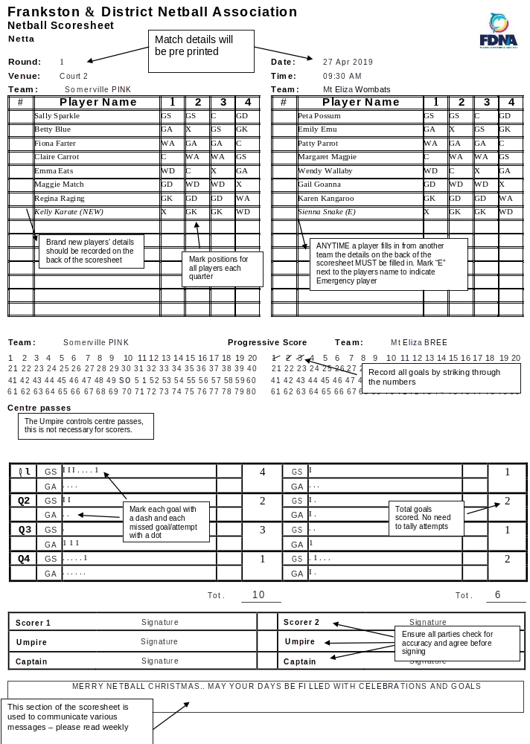
EMERGENCY / FILL IN PLAYERS

Please complete details below for players filling in today:
(mark scoresheet with an “E” next to player name)

example Team name: | Langwarrin White
Player full name: | Mary Jones
Registered/usual team: | Langwarrin Purple
Age group/Section: | 13U C
# Times filled in: | First time

Team name:
Player full name:
Registered/usual team:
Age group/Section:
# Times filled in:

Team name:
Player full name:
Registered/usual team:
Age group/section:
# Times filled in:
Please speak to a member of your Club Committee if you are unsure whether a
player can fill in.

INJURY REPORT
example Player name: | Karen Kangaroo
Club/Team: | Mt Eliza Wombats Netta
Time/Qtr of injury: | 3rd quarter 10am
Injury details: | Sprained tail
Attended First Aid: | YES (circle) NO

Player name:
Club/Team:
Time/Qtr of injury:
Injury details:
Attended First Aid: | YES (circle) NO

All injuries should also be recorded with First Aid provider

PARKING INFORMATION:

Parking is available in the old swimming pool car park accessed directly off Hillcrest Road. Parking is particularly busy at changeover times so please car pool where possible and allow enough time. Drop off zone can be utilized and a limited number of accessible car parks are available.

Spaces are set aside for Physio/First Aid etc. who may arrive during the day so please pay attention to any reserved car parks.

TAKING PHOTOGRAPHS/VIDEO
Most people taking photos or video of children at sporting events are doing so for acceptable reasons and are using appropriate methods.
The courts are governed by FDNA By-Laws & as such we reserve the right to ask Patrons to comply with local rules. We ask that anyone taking photographs or video complete the permission form available at the Timekeeper’s window. This form also requires permission from the opposing team/s. The form asks you to confirm the intended purpose and/or distribution/publication of any images recorded. Once approved, you will be provided with a tag that should be worn & visible at all times.

DOGS/SKATEBOARDS and more….
We ask that all visitors comply with local signage and refrain from bringing Dogs (regardless of whether on a leash) inside the court area. Dogs should be kept outside of the fenced area. This is to ensure the safety of all patrons and to keep our courts clean.
We request that children on Scooters, Skateboards, Rollerblades or other devices leave them outside of the court area. The wheels on these toys can mark the court surface and may also cause injury or concern to other Patrons. If you need to bring a toy, please keep it outside of the courts & please supervise the Child(ren) using it.
Please refrain from walking on designated garden areas.

FIRST AID/PHYSIO

FDNA pride ourselves on the level of service we provide to our players!
We provide HLTAID003 qualified First Aid Officer between 9.30am-1.15pm to attend to any illness or injury. Our First Aid Officer can be found in the First Aid room in the Pavilion (see map).

Peninsula Sports Medicine generously sponsor our competition on Saturdays by providing a qualified Physiotherapist. Our Physio is available between 1.15pm & 4.15pm (BYO tape). The Physio is also located in the First Aid room.

CANTEEN FACILITIES

There is a canteen available in the indoor stadium. The Coffee Gringo provides great coffee outside the stadium and generously donate an amount per cup sold to FDNA every week.
We also offer a range of hot food from our regular food truck vendor.

We are working toward a Healthy Eating menu & the canteen offers a range of home made & healthy options.

HOW DO I FIND WHERE MY TEAM IS PLAYING?

A copy of the fixture is on display in several areas on Saturdays: “The Grid” is displayed on the outside of the Stadium doors, on the blue hanging frame outside the Pavilion as well as on the Saturday Winter Season noticeboard inside the Pavilion. If you have trouble finding any of these Grids please see our friendly volunteers in the Timekeepers Office. Fixtures are available on the MyNetball app.

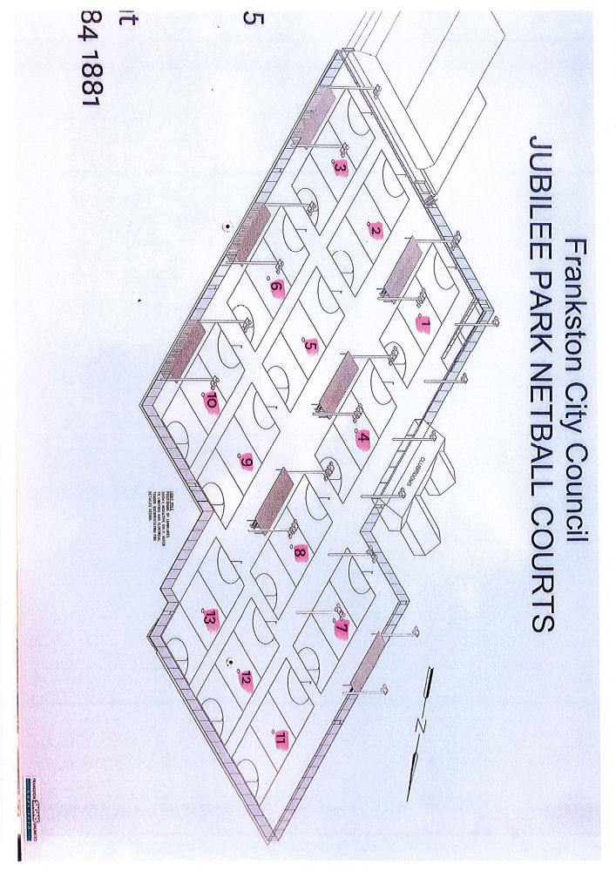

CAN I FILL IN FOR ANOTHER TEAM ON SATURDAYS?

Current By-law 17.1 says:

“Players may play a second game on any given day only to enable the team they are filling in for the field seven (7) players providing:
- The player may only play for an age group or section higher than their own registered team
- The player must cease playing as soon as practicable if the team they are filling in for is able to field seven (7) players after the start of play.”
Written permission from the Coach must be recorded on the Scoresheet. Refer to By-Laws for further information.

QUALIFYING FOR FINALS
Current By-law 19.2 says:

“Players must play a minimum of 2 quarters in 50 percent of the number of weeks fixtured in the season to qualify to compete in the finals. Refer to Qualification Policy endorsed April 2019 & set for annual review.”

CHANGING ENDS
At quarter time & three quarter time teams should change ends quickly without leaving the court. Our centrally timed games allow 2 minutes at half time with no additional time at quarter or three quarter time.
No coaching should occur, other than general direction given whilst the players are changing ends.
COACHES ARE NOT PERMITTED ON THE COURT AT ¼ OR ¾ TIME CHANGEOVERS.
Position changes should occur in the same manner – promptly while moving from one end to the other, without leaving the court.
In hot weather the Umpire may allow players to quickly take a drink during this period; and this shall be at the Umpires’ discretion.

NET SET GO/LOCAL RULES / INDOOR NETTA
We have adopted a set of local modified rules for Netta matches.
We allow 1 Badged umpire only for Netta games and this Umpire will control the whole court

Modified rules for Netta can be read at http://frankstonnetball.com.au/saturday-competition/

LADDERS & RESULTS

In line with Netball Victoria guidelines we do not display results or ladders for any Netta or 11U section. The focus of this age group is participation. We record results to assist with grading and these are not published.
Ladders for all other age groups will be available online from Tuesday mornings after that week’s matches.

TRAINING COURSES

FDNA host a range of learning opportunities for Umpires & Coaches.
These courses are usually emailed to Club Secretaries and can also be found on our website www.frankstonnetball.com.au
Netball Victoria also host a range of Umpiring & Coaching courses & details can be found at www.vic.netball.com.au

GRADING

Volunteer Grading Co coordinator is Anne Westmoreland. A committee is formed prior to the commencement of each season. This Committee is made up of Club Volunteers (nomination forms provided to Clubs), & FDNA Staff.
The Grading Co Coordinator and Committee review team entries to ensure there are no obvious errors.
Members have an opportunity to make recommendations & Anne will then collate teams into sections based on both Grading Committee feedback and the best interests of the whole competition.
We usually fixture approx. 2/3 rounds of grading games depending on calendar for that year. A review takes place after these grading games & changes can be made if the Grading Co Coordinator and committee feel that a team has been graded incorrectly.
Any grading feedback must be submitted to official Grading Co Coordinators in writing.

Special Consideration

In exceptional circumstances players may be granted permission to play in a section or age group that they would not usually be eligible for. Clubs can apply for special consideration in writing & FDNA staff will assess each request on its own merits.
We respect individual differences and abilities & pride ourselves on offering an inclusive competition.
Boys are eligible to play in any age group until they turn 13 years old at which time they can participate in our Mixed competition.

SAFETY & EMERGENCY INFORMATION:
In the unlikely event of an emergency, please follow the instruction of emergency services and / or FDNA Staff. Emergency exits are signed.

EXTREME WEATHER POLICY:
FDNA comply with Netball Victoria Policy. Our staff will communicate to club officials of any changes.

INJURIES:
Injuries should be reported to the First Aid Officer /Physio. First Aid Attendant is HLTAID003 qualified. They will record relevant details. If an injury is/becomes major & a Member needs to make a claim against their VNA membership it is helpful if the injury is recorded at the time.

All Visitors to the complex should adhere to instructions & signage & speak to Staff if there are any safety concerns.

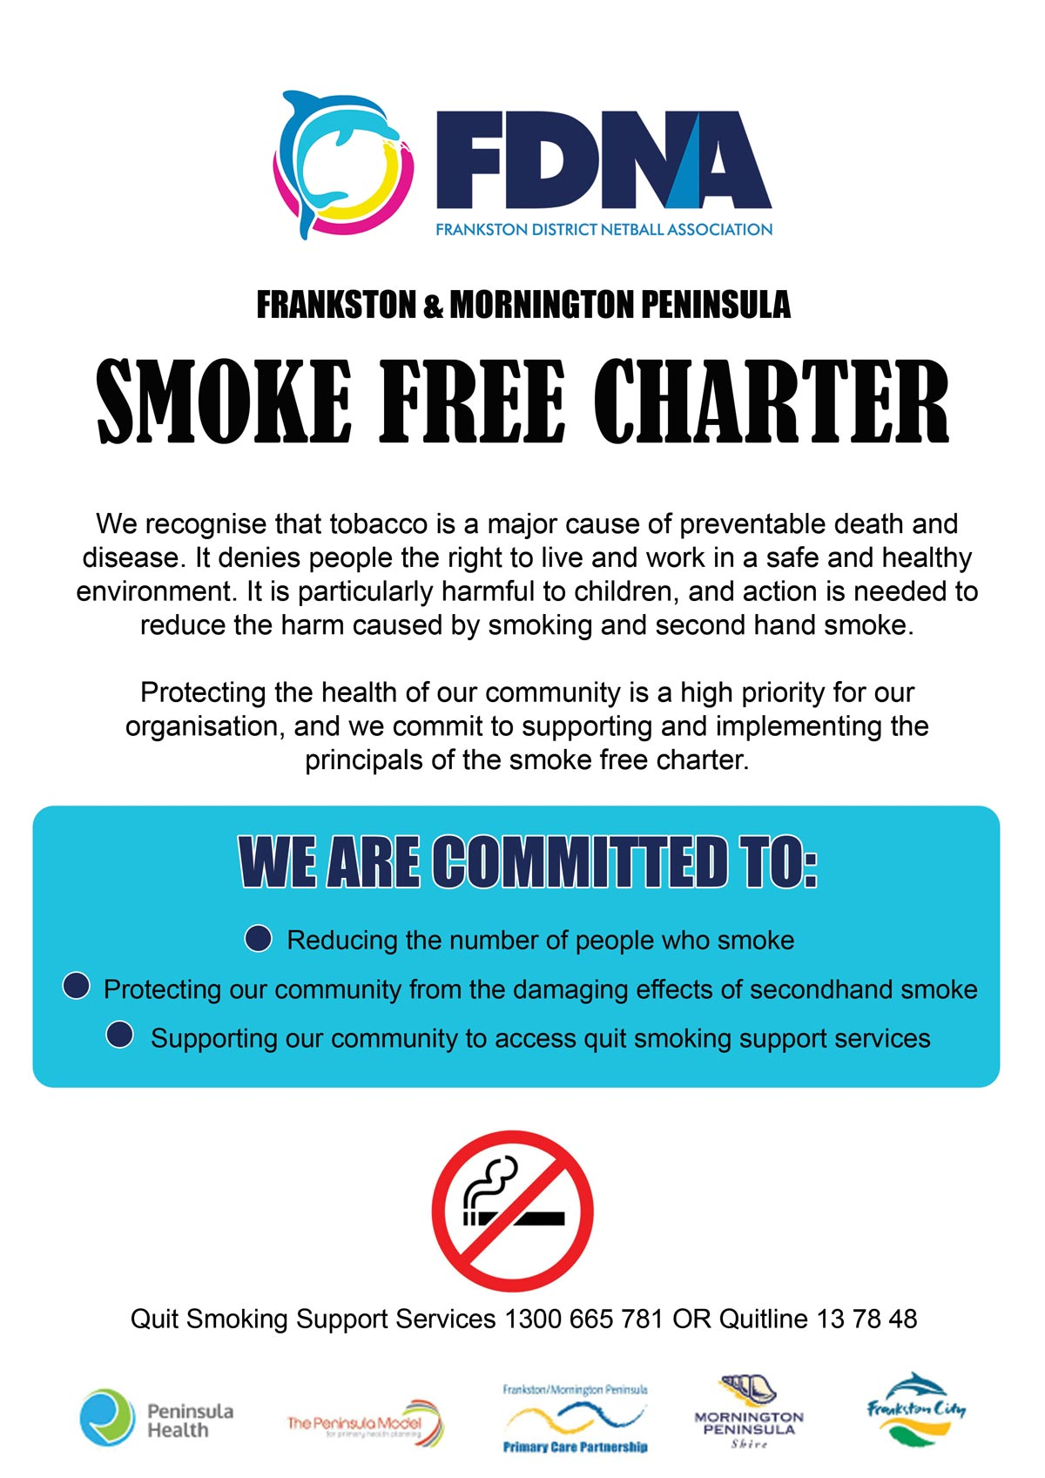


ABN: 16 440 339 856

Postal Address: PO Box 4102, Frankston Heights 3199

Physical Address: (for Deliveries and emergencies)
83R Hillcrest Rd, Frankston
Jubilee Park, Crn Leawarra Parade & Hillcrest Road

Telephone: 9776 5155
Email: saturday@fdna.com.au

